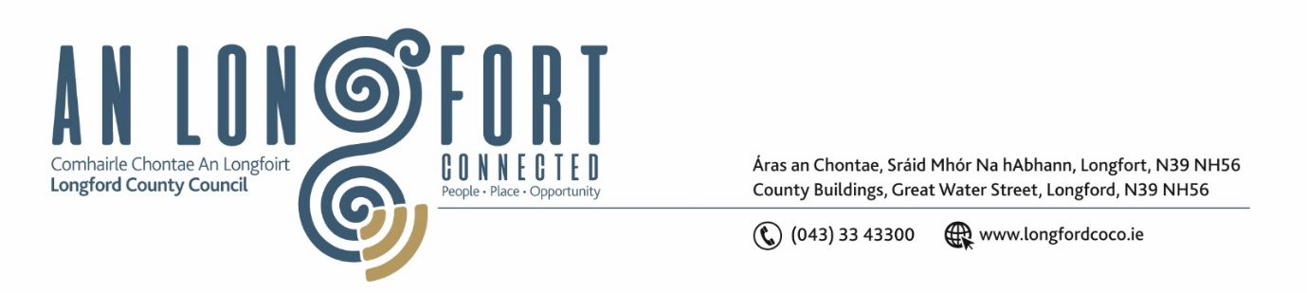

**LONGFORD MUNICIPAL DISTRICT**

***Please note meeting will be held in the Council Chamber, Aras an Chontae and via Microsoft Teams***

**17 January 2024**

**To: Each Member of Longford Municipal District.**

**Dear Member,**

You are requested to attend the Meeting of Longford Municipal District to be held in **the Council Chamber, Aras an Chontae** and **via Microsoft Teams** on **Wednesday 24 January 2024 at 4pm** to transact business, as set out on the agenda hereunder.

**Yours sincerely**,

_______________

**Claire McNabola**

**Meetings Administrator**

**AGENDA**

Prayer before meeting.

**1.** Confirmation of Minutes:

1. Longford Municipal District Meeting held on Wednesday 22 November 2023 – enclosed.

**2.** Matters arising from Minutes.

**3.** Declaration of Interest by Members.

**4.** Management Report

**5.** **Notices of Motions, submitted by Councillors, as listed hereunder –**

**Councillor Seamus Butler**

1. Due to frequent parking on the Ballinalee Road entrance to College Park causing difficult ingress and egress, I propose that double yellow lines be added from the Ballinalee Road at least 50m into College Park on each side of the road.
2. I propose that the Courthouse Alley off Main Street be taken in charge by Longford County Council, using a CPO if necessary.

**Councillor Gerry Hagan**

1. I call on Longford MD to include the stretch of road (L1011), from Kiernan’s Forge Crossroads to the crossroads at Melview on the winter salting/gritting program.

**Councillor Martin Monaghan**

1. I propose that the parking times be revised in Longford town from 9am to 5pm.I believe that this amendment to parking times would benefit businesses and the public.

1. That the manhole covers on the east side of the Market Square at the junction with Earl Street be made level with the road surface.

**6.** **Correspondence**

**(i)** Updatedcorrespondence received fromUisce Eireann re. Taking in Charge of infrastructure in Cartrun Breac Estate – enclosed.